Name: Period:
BOND ENERGY/ENTHALPY WORKSHEET
Due: Tuesday May 12th, 2020

Use the following table to answer the questions. All the value are in kJ/mol

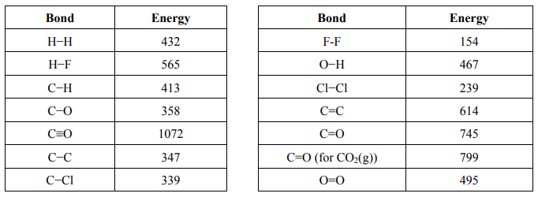

PART 1: calculate the enthalpy change of ΔH_{rxn} of the following reactions using the bond energies above.

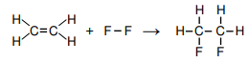

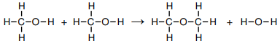

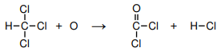

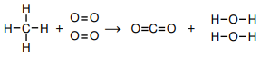

PART 2: Draw the Lewis structure for each reactants and products. Estimate the enthalpy change for the reaction using bond energies

- H₂ + CO₂ → H₂O + CO

- 2H₂O₂ → 2H₂O + O₂

- N₂ + 3H₂ → 2NH₃

- H₂ + C₂H₄ → C₂H₆

- 2C₂H₆ + 7O₂ → 4CO₂ + 6H₂O

- HCN + 2H₂ → CH₃NH₂

