Calorimetry Critical Thinking

What is the relationship between heat energy and temperature?
IMPORTANT: PLEASE TYPE YOUR ANSWER IN BLUE INK

Why?

When a substance is heated, the temperature of that substance increases. Will the same amount of energy cause different substances to have identical temperature increases? Will the same amount of energy be needed to cause identical temperature increases in different amounts of the same substance? In this activity you will explore how mass, temperature, heat energy, and the type of substance are related.

Model 1 – A Pot of Water
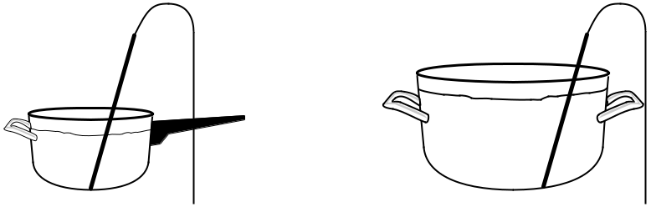

Before heating

4 qt. saucepan |  | 8 qt. stockpot
 | 24.5 °C |  | 24.5 °C
 | Temp. |  | Temp.

After heating for 5 minutes at
a rate of 30 Joules per minute
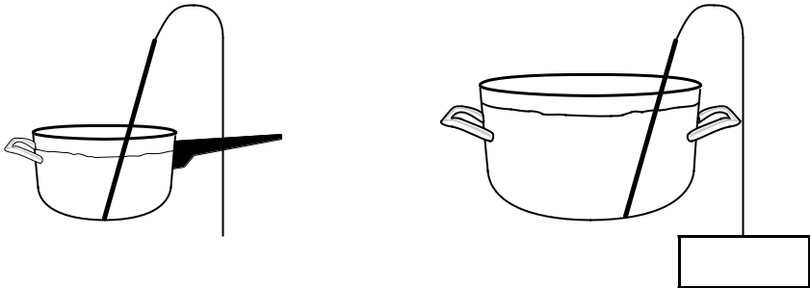

4 qt. saucepan |  | 8 qt. stockpot

Temp. Temp.

- 1. In Model 1, which container holds more grams of water?

- 2. Consider the process described in Model 1:

  - How many joules of energy were added to the saucepan?

  - How many joules of energy were added to the stockpot?

  - In which container did the liquid gain more energy or did both gain the same amount? Explain your reasoning.

  - For each container, include whether the temperature is expected to increase, decrease or remain the same after heating. Explain your reasoning.

Calorimetry 1

Model 2 – Experimental Data for Heating Water

Experiment 1

Trial | Mass (g) | T (°C) | Added Energy (Joules)
A | 1.00 | 26.8 | 112
B | 2.00 | 13.4 | 112
C | 2.50 | 10.7 | 112
D | 3.00 | 8.93 | 112
E | 3.50 | 7.66 | 112
F | 4.00 |  | 112
Experiment 2

Trial | Mass (g) | T (°C) | Added Energy (Joules)
A | 3.00 | 3.00 | 37.6
B | 3.00 | 6.00 | 75.2
C | 3.00 | 9.00 | 113
D | 3.00 | 12.0 | 150
E | 3.00 | 15.0 | 188
F | 3.00 | 18.0
Experiment 3

Trial | Mass (g) |  | T (°C) | Added Energy (Joules)
A | 1.00 |  | 9.00 | 37.6
B | 2.00 |  | 9.00 | 75.0
C | 2.50 |  | 9.00 | 94.1
D | 3.00 |  | 9.00 | 113
E | 3.50 |  | 9.00 | 132
F | 4.00 |  |  | 150
3. In the data tables in Model 2, what does |  | T mean?

- Which experiment in Model 2 illustrates how the amount of energy needed to achieve the same temperature change depends on the mass of water?

- Which experiment in Model 2 illustrates how different amounts of energy result in different temperature changes when the mass of water is constant?

6. Why was it necessary to perform three experiments to find the relationships between mass, temperature change, and energy?

2 Activities for High School Chemistry

- 7. Refer to Experiment 1 in Model 2, and consider the relationship between the mass of water and the observed temperature change when the same amount of energy is added.

  - Complete the statement below to show the relationship. (highly your selection in blue)

When the same amount of energy is added to water samples of different mass, the change in temperature gets (smaller/larger) as the mass of the water increases.

  - Does the relationship stated in part a describe a direct or inverse relationship?

- 8. Refer to Experiment 2 in Model 2.

  - Write a grammatically correct sentence (like the one in Question 7a) to describe the relationship between the observed temperature change and the energy required to heat water samples of identical mass.

  - Does the relationship stated in part a describe a direct or inverse relationship?

- 9. In Experiment 2, should the value of the missing energy in the last row be larger or smaller than the other energy values in that column?

10. Refer to Experiment 3 in Model 2.

a. Write a grammatically correct sentence to describe the relationship between the mass of water and the energy required to produce the same temperature change in different water samples.

b. Does the relationship stated in part a describe a direct or inverse relationship?

11. Each of the experiments in Model 2 can be expressed as a proportionality indicated by the following symbol: ∝. Several possible equations are shown in the table below.

q |  | ∝ | m | q | ∝ | 1/m
q |  | ∝ | T | q | ∝ | 1/ T
 | T | ∝ | m |  | T ∝ | 1/m
a. Describe what each variable represents in the equations shown above?
m = |  |  |  |  |  | T = |  | q =

- For each experiment in Model 2, indicate which of the six proportionalities shown in the table above correctly describes the relationship observed by the results of that experiment.

Experiment 1 Experiment 2 Experiment 3

Calorimetry 3

12. Based on your answers in Question 11, write a single proportionality statement that includes all three variables: q, m, T. The statement should use q as the variable on the left.

13. A proportionality statement can become an equation when a constant is determined. The equa-tion will have q on the left side of the equal sign and a constant “c” on the right side of the equa-tion. Re-write the proportionality statement from Question 12 as an equation using “c” for the constant. After reaching consensus on this equation in your group, compare your answer with other groups to verify your equation.

- Solve for the value of the constant “c” using data from Model 2. Your teacher may assign you a specific experiment to use. Your group should calculate the value of c by using one set of data from each of the three experiments (include the units of this constant). After you complete the three calculations, compare your value for the constant with the value that other groups determined.

- The constant obtained in Question 14 is called the specific heat, (c). It is an intensive physical property that has a different, characteristic value for every substance. What is the value for the specific heat of water?

16. What do the units for specific heat mean? (Make sure your answer is a grammatically correct sentence.)

- Using your equation for energy transferred (q) from Question 13 and the calculated value for the specific heat of water, determine the amount of energy required to increase the temperature of 550 grams of water by 20.0 °C.

- Using your equation for transferred energy (q) and the specific heat, determine the values for the missing data in the three experiments in Model 2. (Trial F in experiments 1–3.)

19. Use your equation from Question 13 to calculate the following:

- How much energy is transferred when 30.0 g of water is cooled from 25.0 °C to 12.7 °C.

- Describe the significant difference between this value and the energy values shown in Model 2.

4 Activities for High School Chemistry

Extension Questions

Model 3 – Heating Mercury and Water

Trial | Substance | Mass (grams) | T (°C) | Added Energy (Joules)
1 | Hg | 100.0 | 71.0 | 1,000.0
2 | Hg | 100.0 | 142 | 2,000.0
3 | H₂O | 100.0 | 2.39 | 1,000.0
4 | H₂O | 100.0 | 4.78 | 2,000.0

- What two substances are being heated in the experiments described in Model 3?

- Compare any two trials in Model 3 that use the same amount of energy but involve different substances. Is the temperature change the same or different in the two trials?

- Based on the data in this activity, the specific heat of water was determined to be 4.18 J/ g°C. Use data from Model 3 to solve for the value of the specific heat for mercury.

- Select the correct word to complete the sentence:

When adding the same amount of energy to two similar massed samples, the substance with the larger specific heat will have a (larger or smaller) temperature change?

- If 23,000 joules of energy are used to heat water by 4.00 °C, what is the mass of the water?

- If 23,000 joules of energy are used to heat mercury by 4.00 °C, what is the mass of the mercury?

- What is the specific heat of aluminum if 4,750 joules of heat energy added to 249 g of aluminum produces a recorded temperature change of 21.1 °C?

Calorimetry 5

