Calorimetry Virtual Lab Name:_____________________Period:_____
Follow the procedures below. Make sure to answer the questions in bold/italics.
- Open your web browser and open the following link http://www.classzone.com/books/hs/ca/sc/bio_07/virtual_labs/virtualLabs.html

- Central Question: How much energy is in the food you eat. Make sure the volume is turned on for the computer. Or if it is annoying to have volume you can also just READ.

- In your own words, what is the goal of the investigation?

- Click on the EXPLORE tab on the top right of the screen. Click on each item of the checklist.
- Now match the following checklist items to their picture:
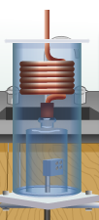 |  | 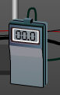 | 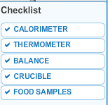  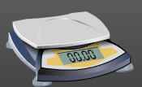
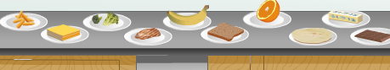

- Click on the PROCEDURE tab on the top right of the screen.

- Select five food samples and drag to table. Record in the LAB NOTEBOOK at the top right of the screen your PREDICTIONS as to which will have the fewest Calories to greatest Calories per gram.

- Now record your predictions in the table below (note, they do not have to be the same as your group members
1. | (fewest number of Calories per gram)
2.
3.
4.
5. | (greatest number of Calories per gram)

- Click on the ARROW to go to STEP 2 of 15

Continue on the next page
- Follow the instructions where you will perform the experiment for each of the five samples you selected. After you have completed the 5th sample copy the data from the LAB NOTEBOOK in the table below. *** You must do it for BOTH the computer and copy below***

Table 1: Data Collection for Food Samples
Food Sample | Initial Mass Food sample with Crucible (g) | Final Mass Food sample with Crucible  (g) | Change in Mass (g) | Initial Water Temp (⁰C) | Final Water Temp (⁰C) | Change in Water Temp  (⁰C)

- When you are done with the Procedure. You will open up the LAB NOTEBOOK to perform the CALCULATIONS. Please perform on this paper as well as in the LAB NOTEBOOK to help you.
- To calculate the number of Calories released by the food sample, use the following formula:
Q=mCΔT (We Learned this last week)
Q= Calories in food sample
m= mass of water (600g)
C= specific heat of water 1 cal/g⁰C. (1 calory = 4.184J). This is using food Calories, so it also has you divide by 1000
ΔT= change in temperature
Simply fill in the change in temp for each food sample (found at the bottom the lab notebook) and it will give you Calories. Fill in you answer on the chart for Table 2 Below

- The last calculation is important so that you are comparing foods per gram. To calculate the Calories per gram (Cal/g) use the following formula:
$$Calories per gram \left(\frac{Cal}{g}\right)=\frac{Calories in Food sample (Ca)}{Change in mass of the sampel(g)}$$
Simple fill in the Calories in Sample calculated in Step 1 and recorded in Table 2 and the Change in Mass (g) from Table 1 and Table 2 and the computer will give you your answer. Fill in your answer on the chart for Table 2 Below.

Table 2: Analysis for Food Samples
Food Sample | Change in Mass (g) | Change in Water Temp (⁰C) | Calories in Sample (Cal) | Calories per Gram (Cal/g)

- Analysis and Conclusion: (You do not need the computer)
- Rank your foods according to your results.

1. | (fewest number of Calories per gram)
2.
3.
4.
5. | (greatest number of Calories per gram)

b. Look back at your predictions. Were they correct?

- What is the relationship between the release of energy as heat and your calculation of Calories?

- How could this information be useful to help plan a healthy diet? (Please explain with at least 5 QUALITY sentences).

